1. Write a program in C to read n number of values in an array and display them in reverse order.

Test Data :

Input the number of elements to store in the array :3

Input 3 number of elements in the array :

element - 0 : 2

element - 1 : 5

element - 2 : 7

Expected Output : The values store into the array are : 2 5 7

The values store into the array in reverse are : 7 5 2

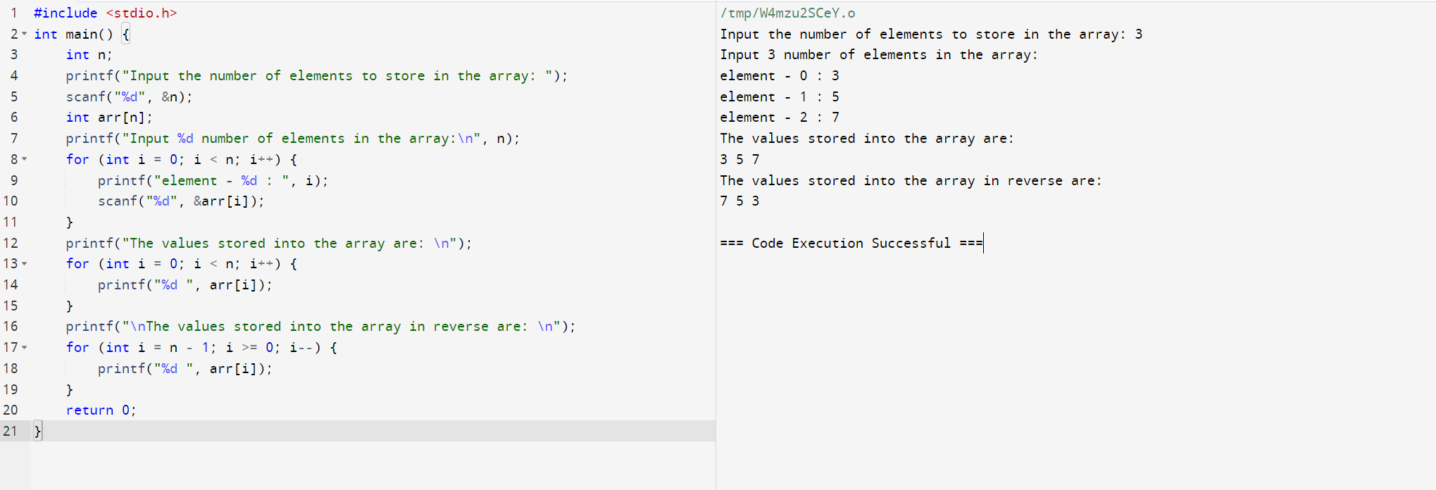

2.Implement a C Program for AVL tree and perform Insertion and Deletion of Nodes

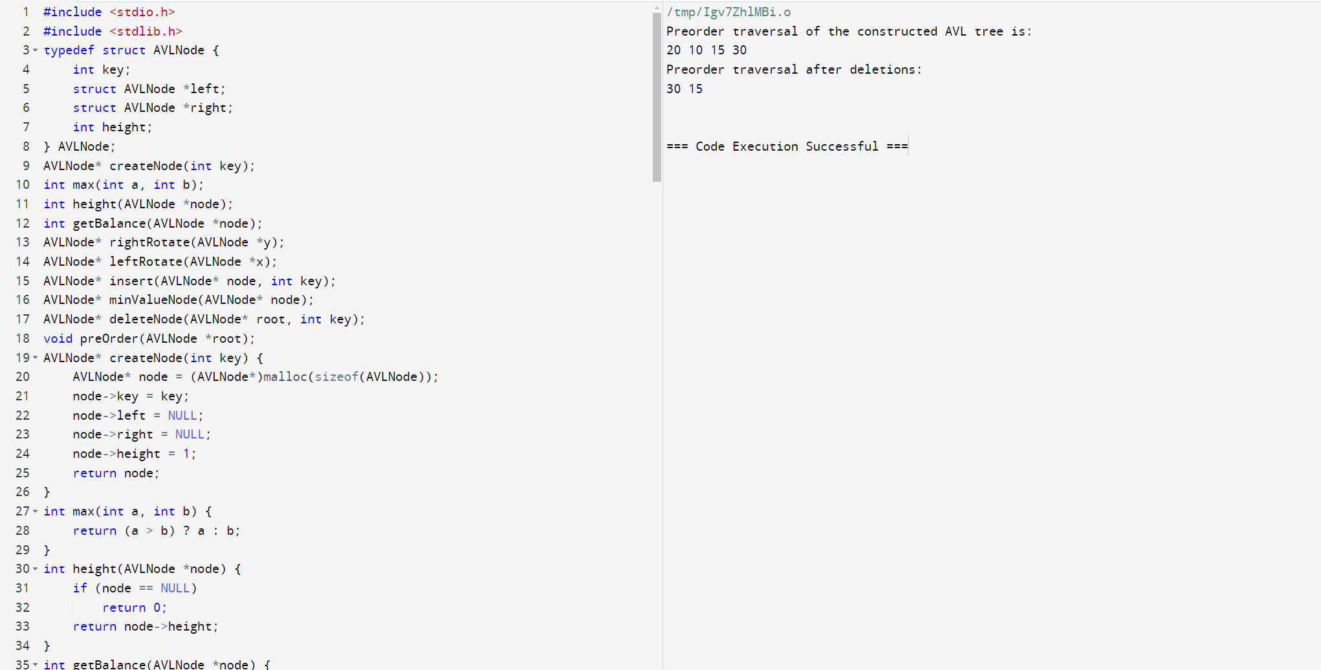

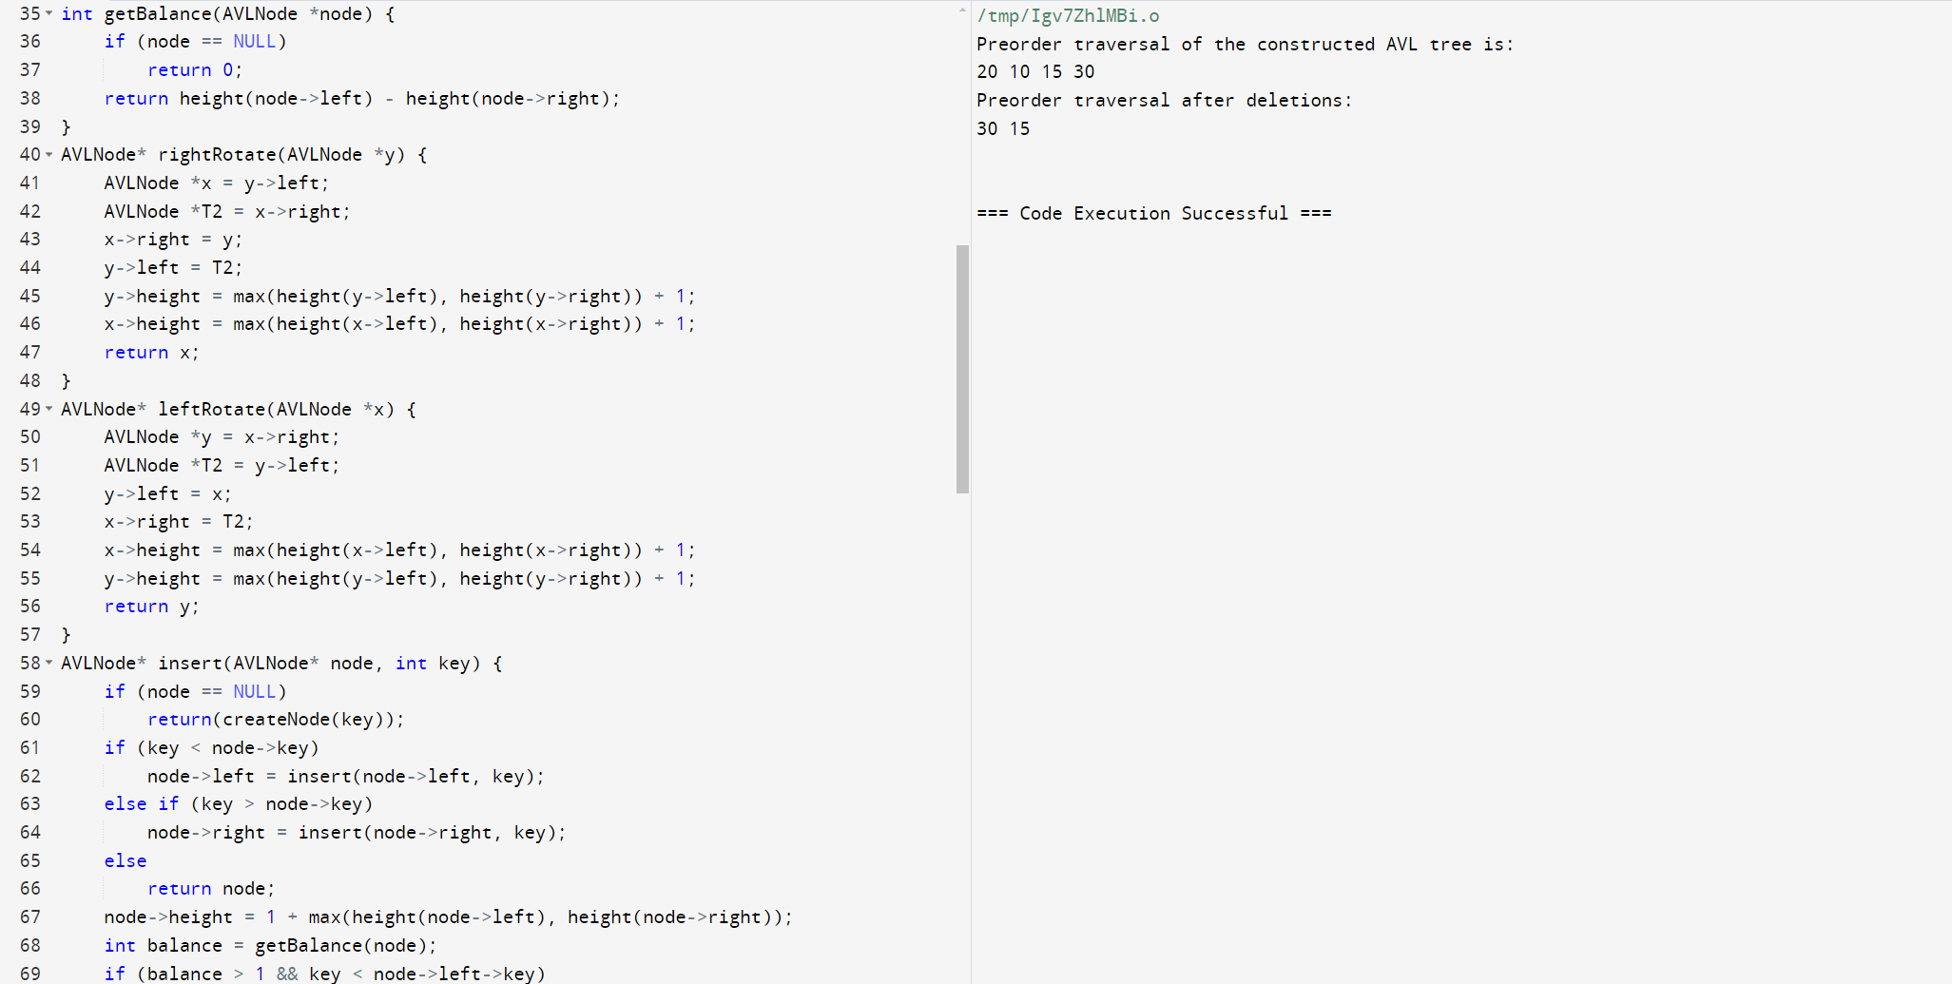

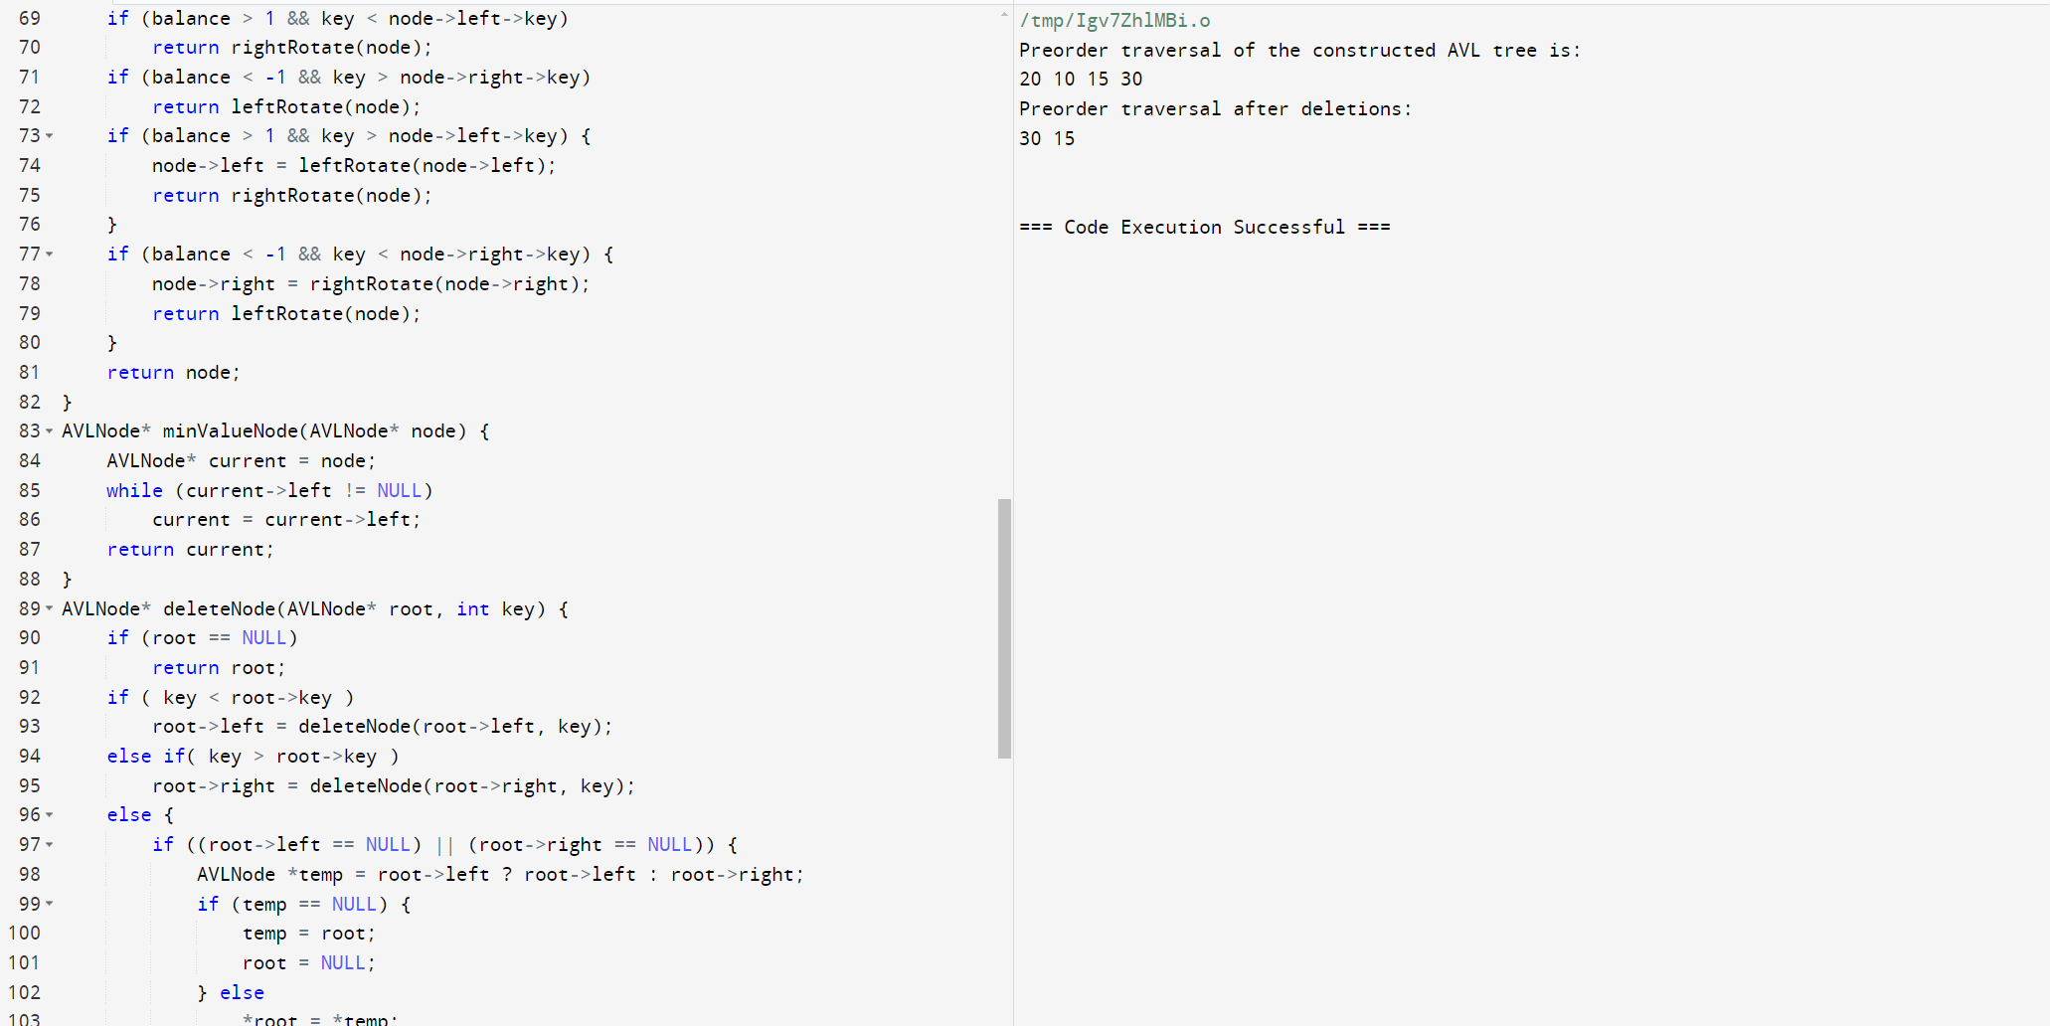

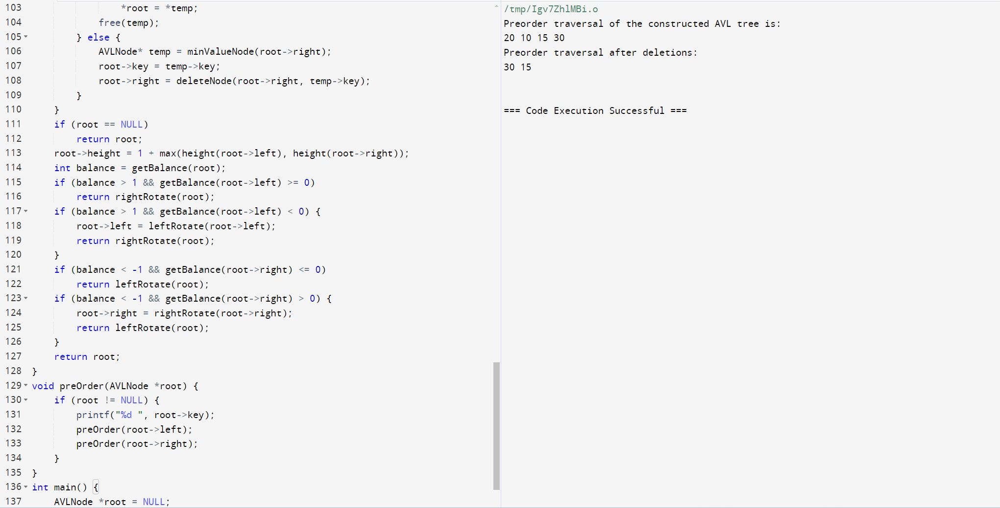

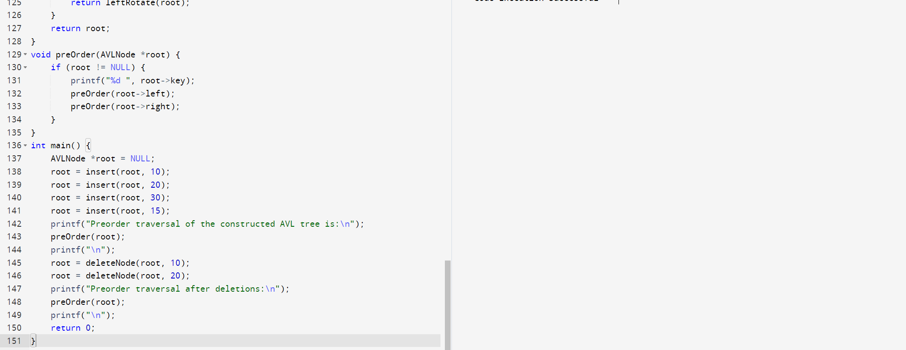

3.Implement a C Program to Check for a valid String.

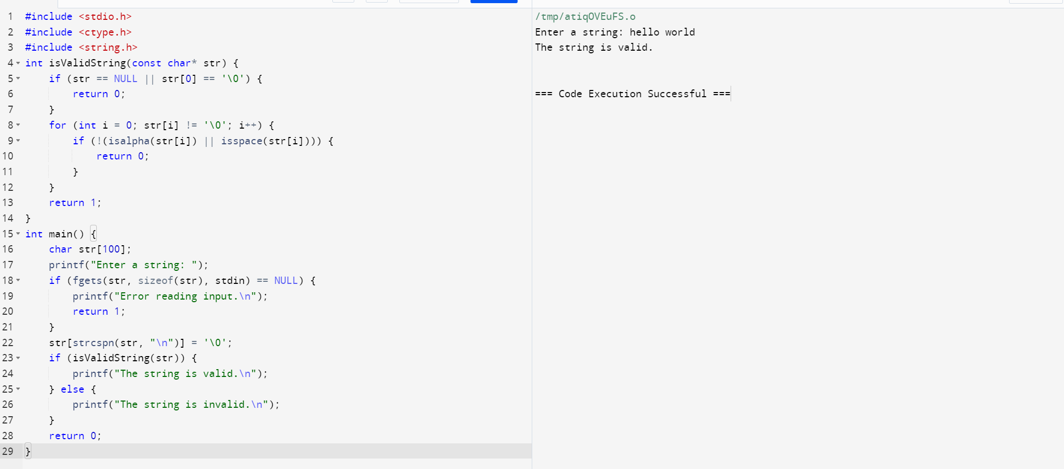

4. Implement a C Program whether it is a Valid stack

Input: pushed = { 1, 2, 3, 4, 5 }, popped = { 4, 5, 3, 2, 1 }

Output: True Following sequence can be performed: push(1), push(2), push(3), push(4), pop() -> 4, push(5), pop() -> 5, pop() -> 3, pop() -> 2, pop() -> 1

Input: pushed = { 1, 2, 3, 4, 5 }, popped = { 4, 3, 5, 1, 2 }

Output: False 1 can't be popped before 2.

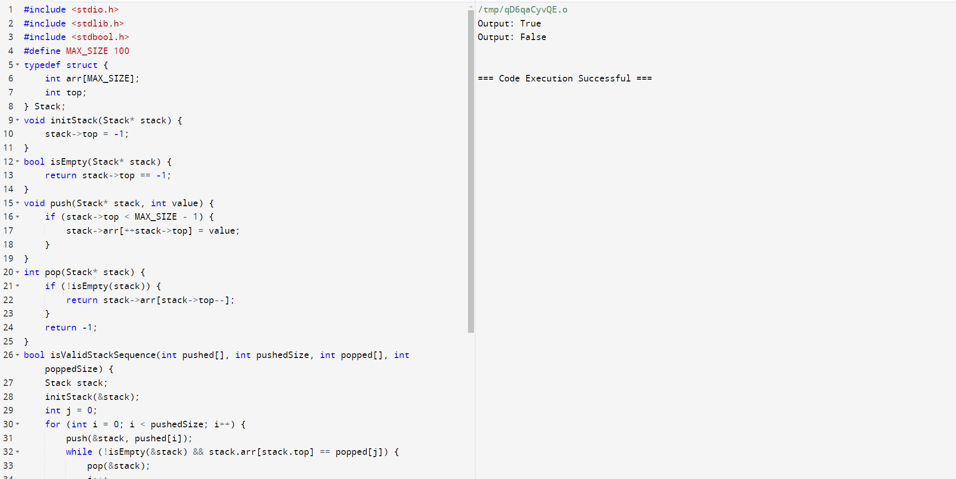

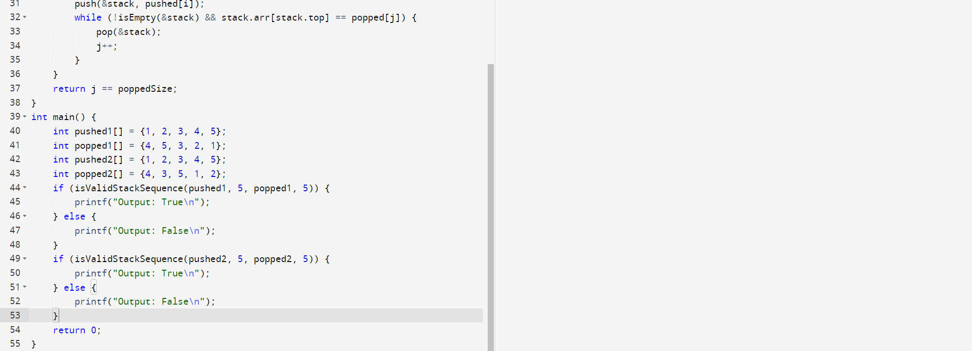

5. Implement a C Program to Merge two Arrays

Input: arr1 = [1, 2, 3, 4, 5]

arr2 = [6, 7, 8, 9, 10]

Output: arr3 = [1, 2, 3, 4, 5, 6, 7, 8, 9, 10]

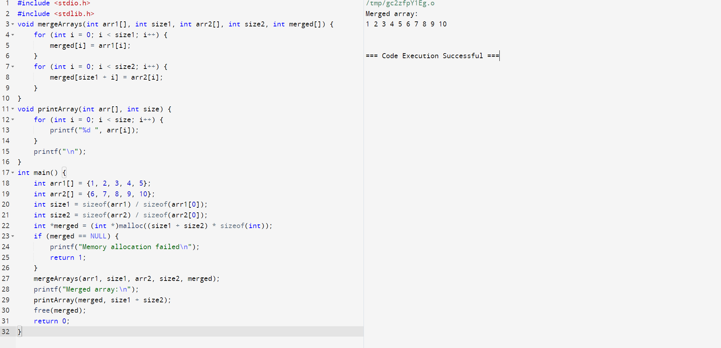

6. Implement a C Program for Graph to Identify shortest path

Input : Enter number of nodes 4

Enter weight of all the paths in adjacency matrix form

0 10 30 100

10 0 10 90

30 10 0 30

100 90 30 0

Enter the source 1

Enter the target 4 1 to 2 to 3 to 4

Output: shortest path is 50

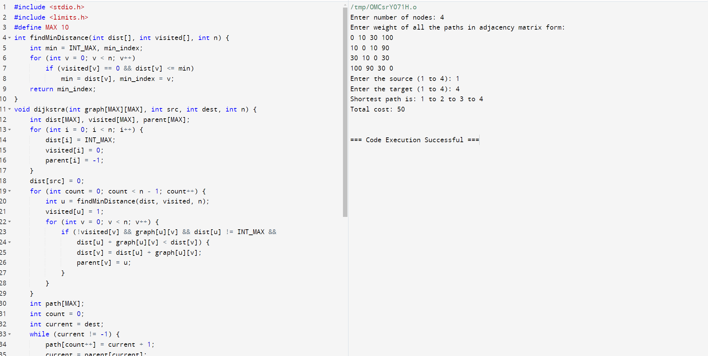

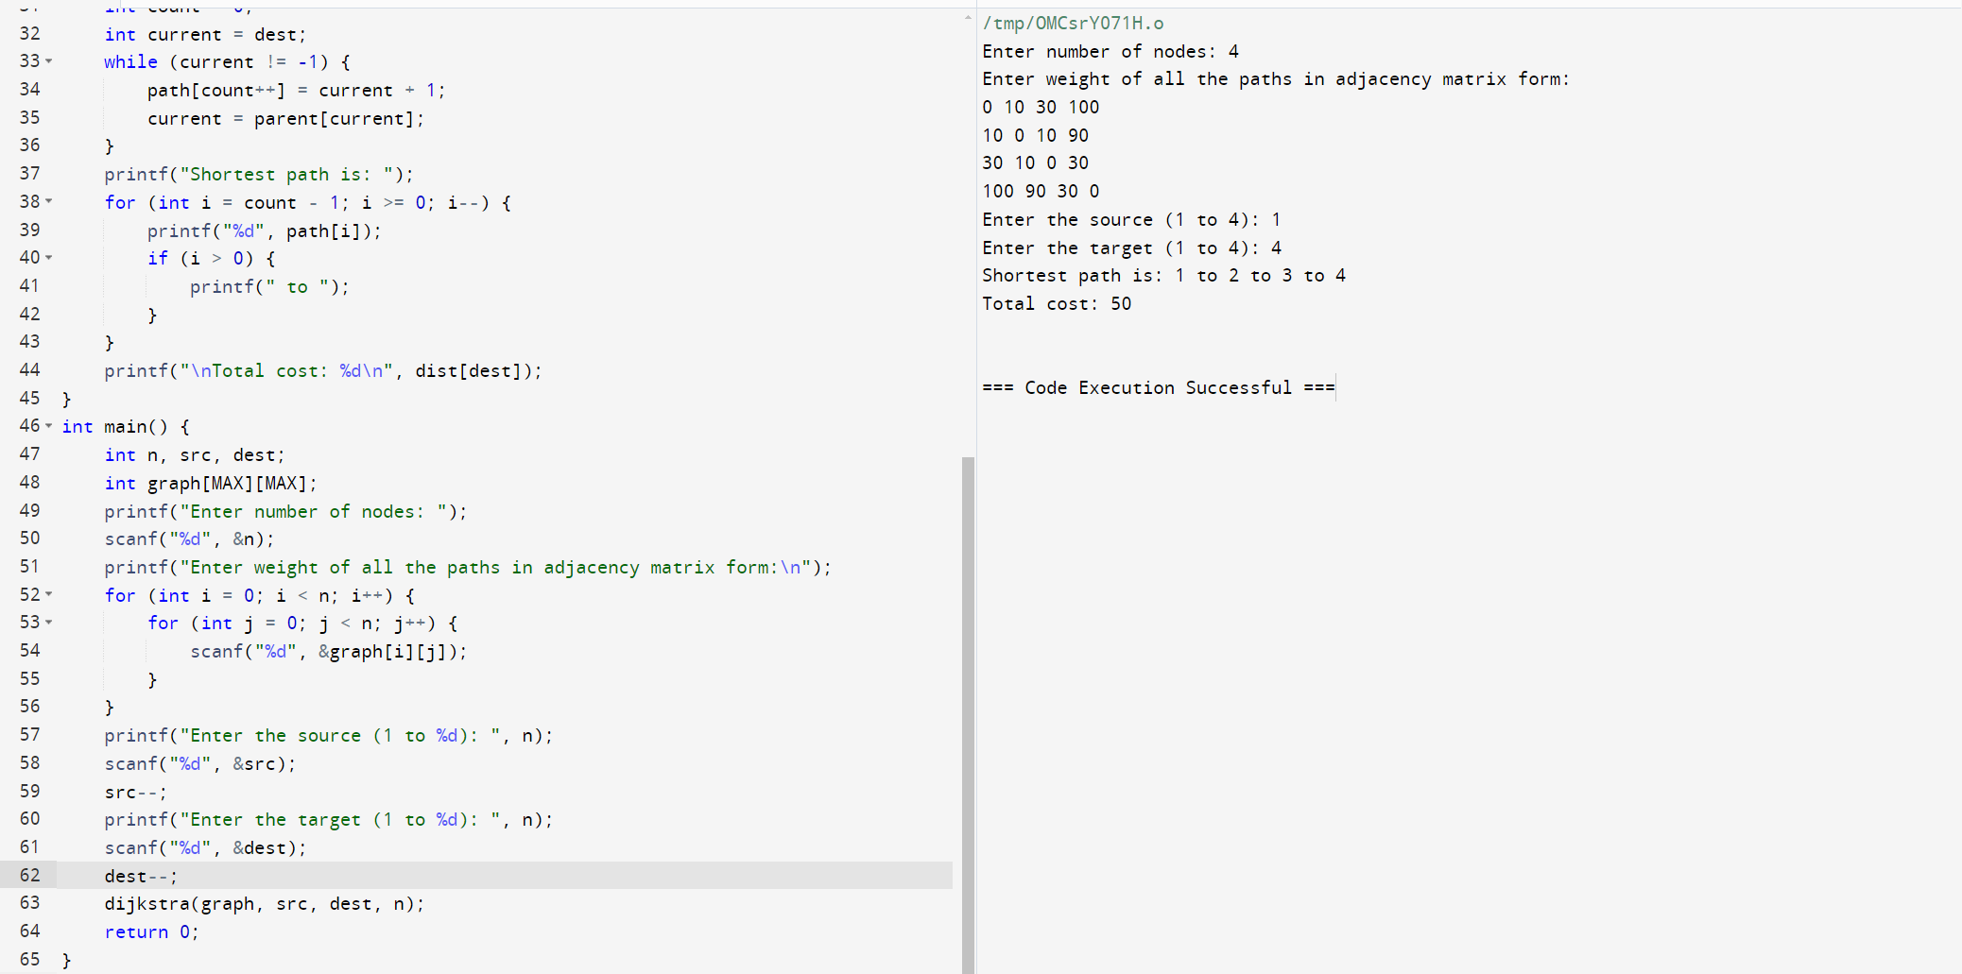

7.Write a program in C to count the total number of duplicate elements in an array. Test Data : Input the number of elements to be stored in the array :3

Input 3 elements in the array :

element - 0 : 5 element - 1 : 1

element - 2 : 1

Expected Output : Total number of duplicate elements found in the array is : 1

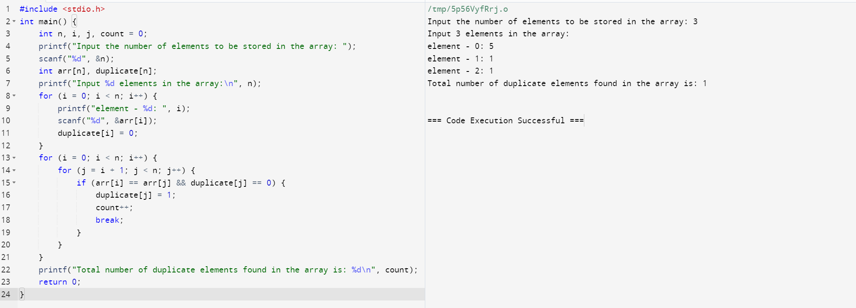

8. Implement a C Program Traveling Salesman Problem to Identify shortest path Given a set of cities and distances between every pair of cities, the problem is to find the shortest possible route that visits every city exactly once and returns to the starting point.

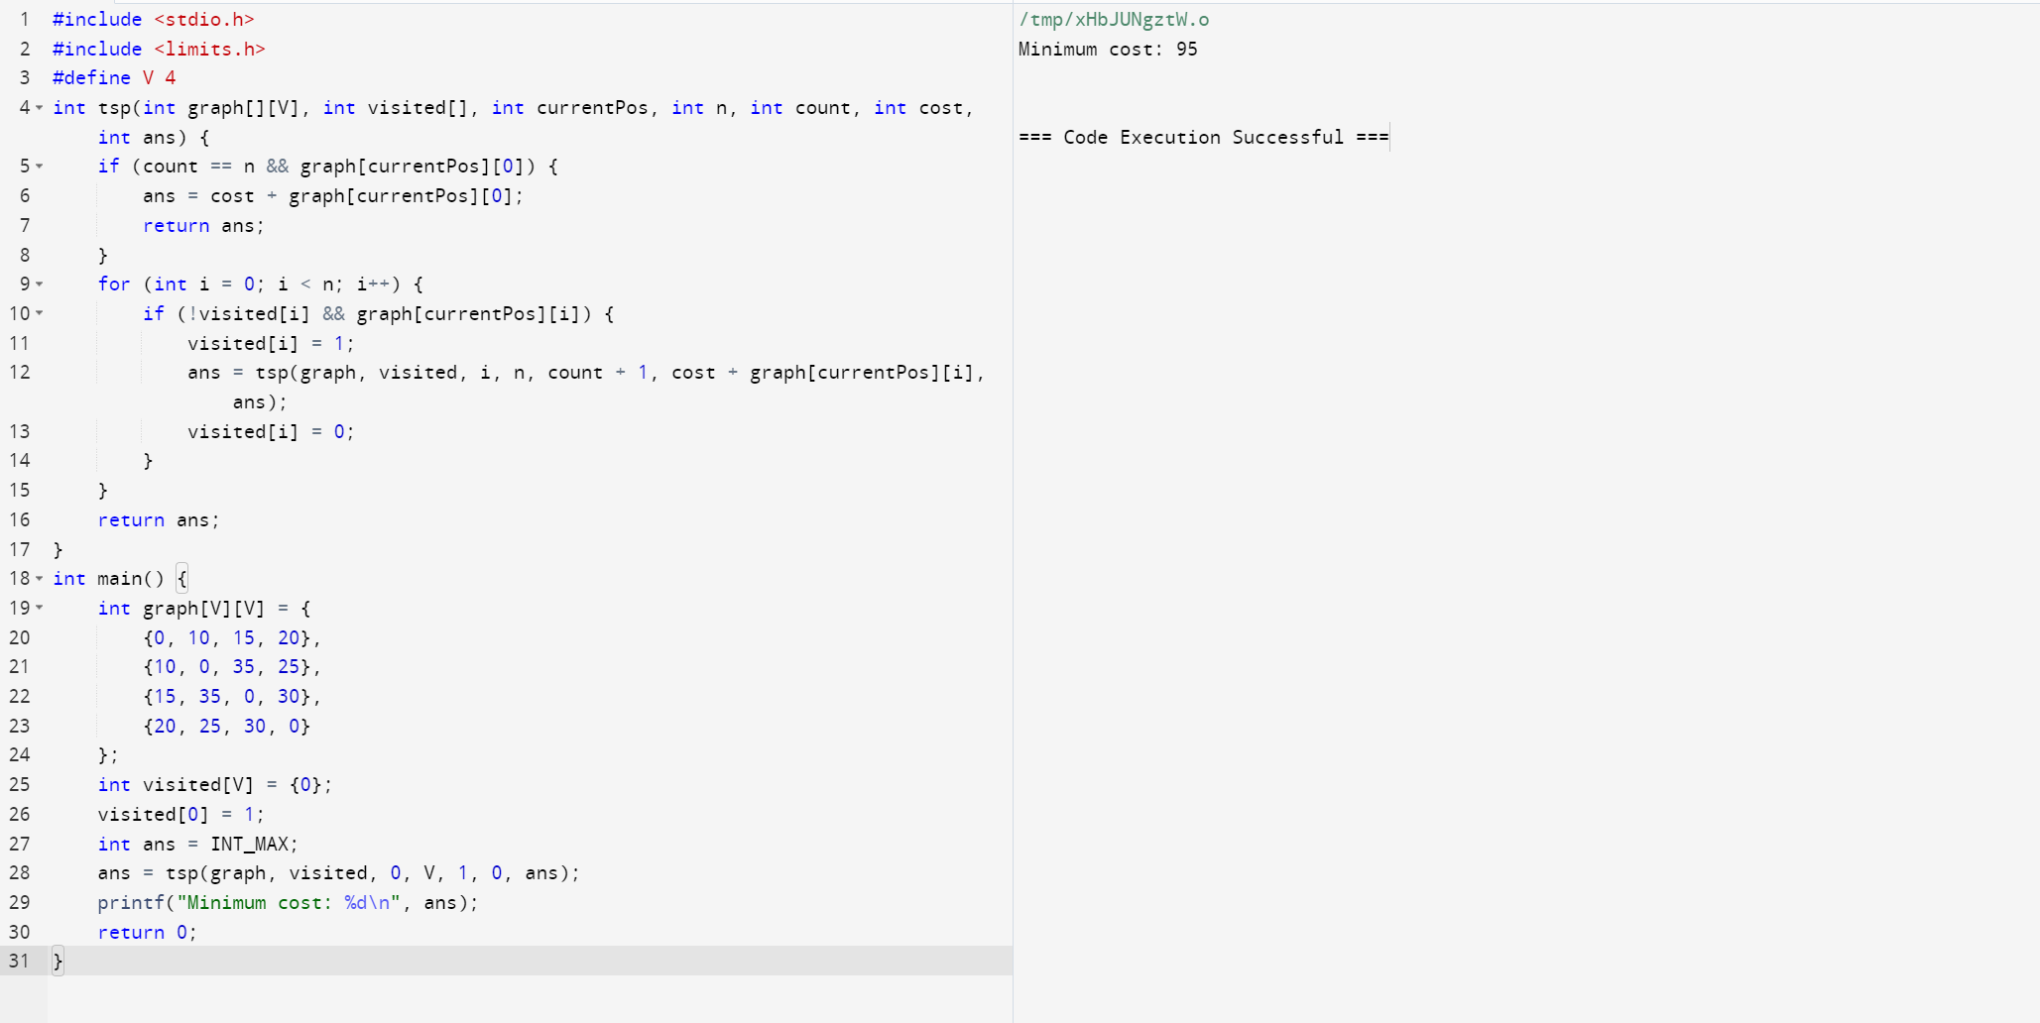

9. Implement a C Program for Merging of list.

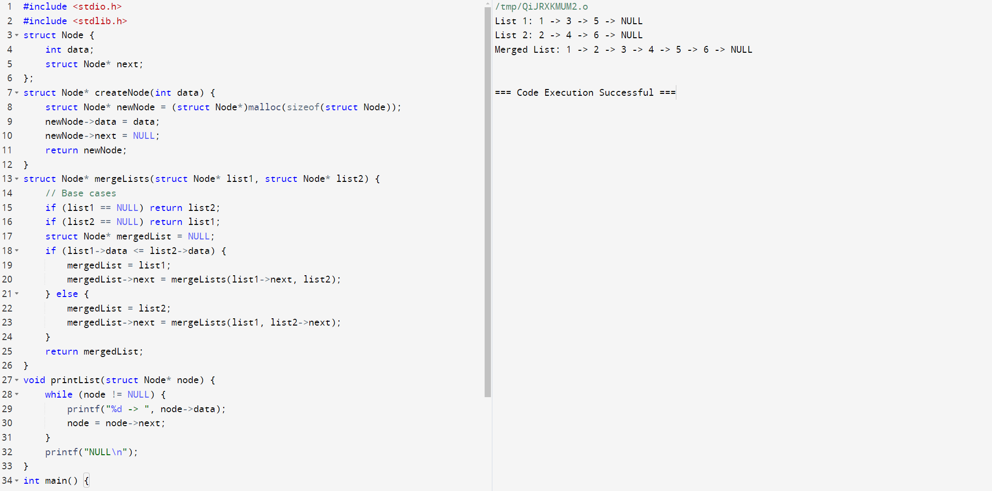

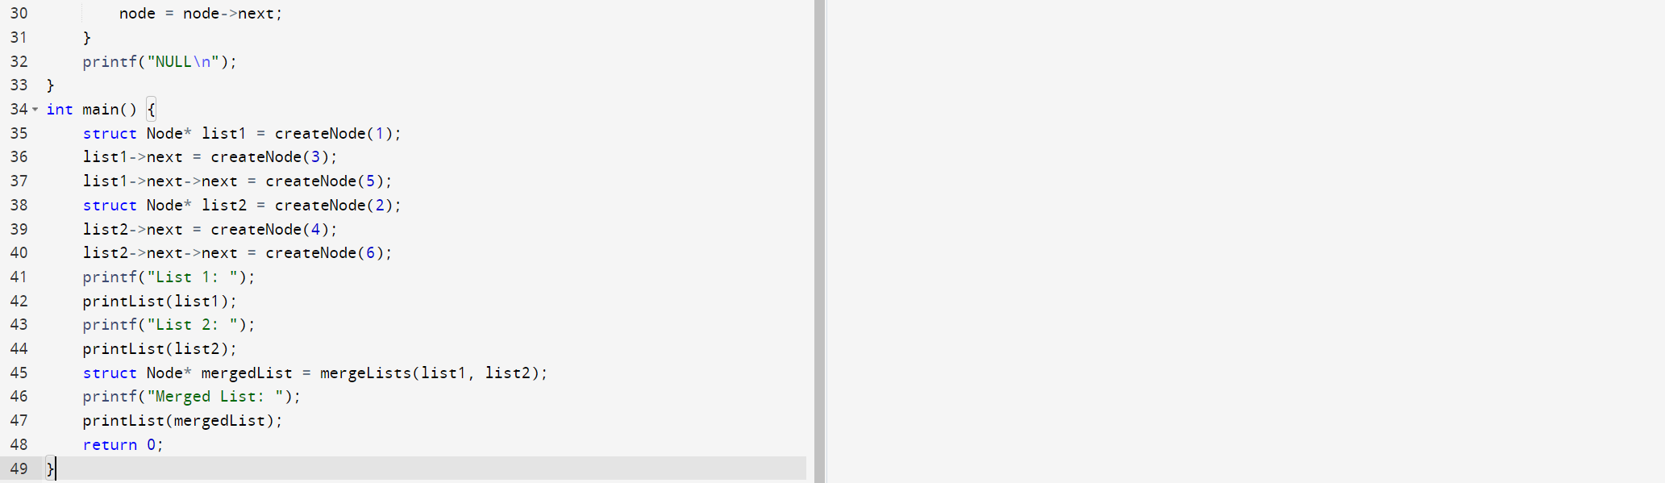

10. Implement a C Program for Binary search tree - search for a element, min element and Max element

